The 18th of May.
Final test
1 task: a) Match the words in the two columns
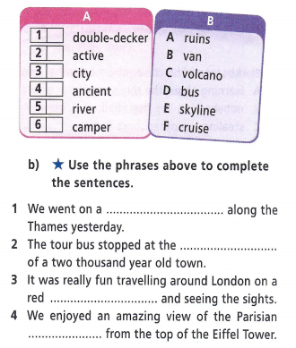
2 task: Open the brackets, using the present perfect tense
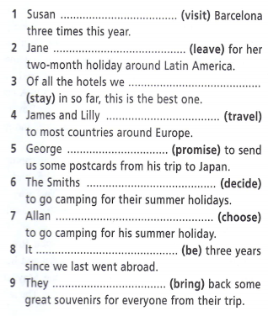
3 task: Put the words in brackets into past simple or present perfect tenses:
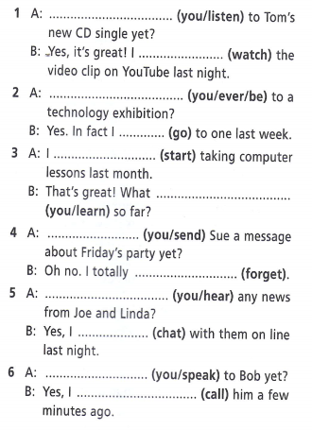
Home work: не задано

