ФИ________________________________________________
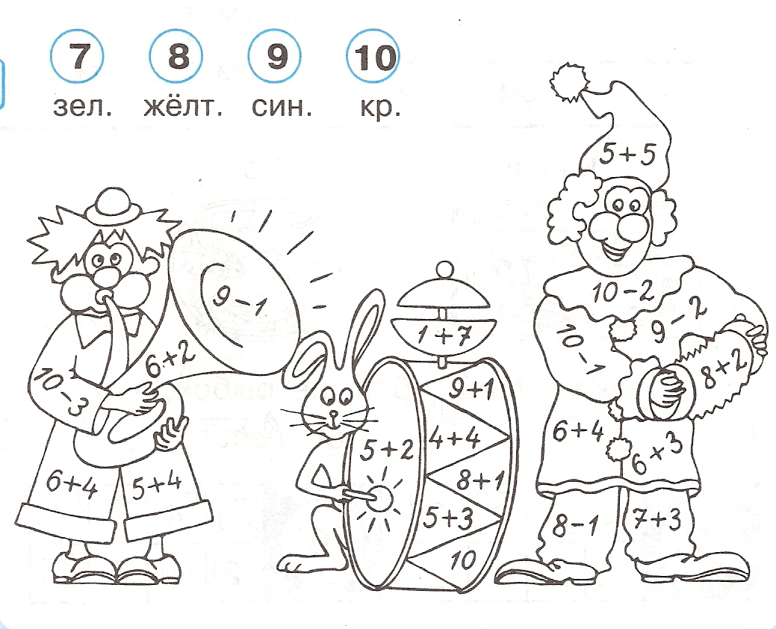

ФИ ____________________________________________

